9/18/2022

Programming Fundamental

Quiz#01

Abdullah Shafiq

22K-4489

**[A]** What would be the output of the following programs:

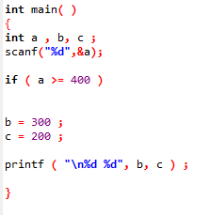

(a)

***OUTPUT:***

Value of “c” i-e 200.

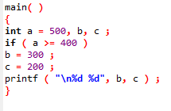(b)

***OUTPUT:***

b=300 and c=200.

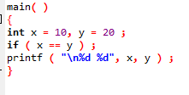(c)

***OUTPUT:***

x=10 and y=20.

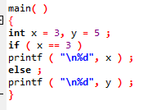

(d)

***OUTPUT:***

x and y are equal.

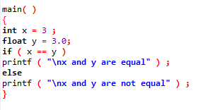(e)

***OUTPUT:***

x=y=10 and z=0

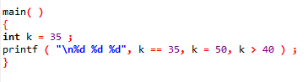

(f)

***OUTPUT:***

0 , k=50 , 0

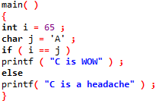(g)

***OUTPUT:***

WOW.

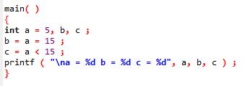

(h)

***OUTPUT:***

a=15, b=15 and c=0.

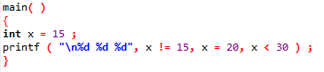(i)

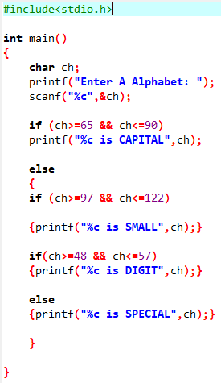

***OUTPUT:***

1, x=20, 0,

**[F]** Attempt the following:

**(a)** Any year is entered through the keyboard, write a program to determine whether the year is leap or not. Use the logical operators **&&** and **||**.

***CODE:***

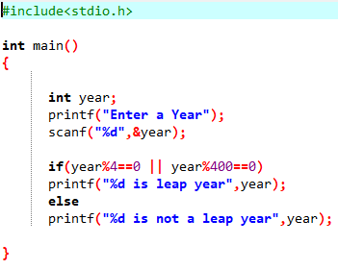**(b)** Any character is entered through the keyboard, write a program to determine whether the character entered is a capital letter, a small case letter, a digit or a special symbol.

***CODE:***

**(c)**Write a program to output whether the person should be insured or not, his/her premium rate and maximum amount for which he/she can be insured.

***CODE:***

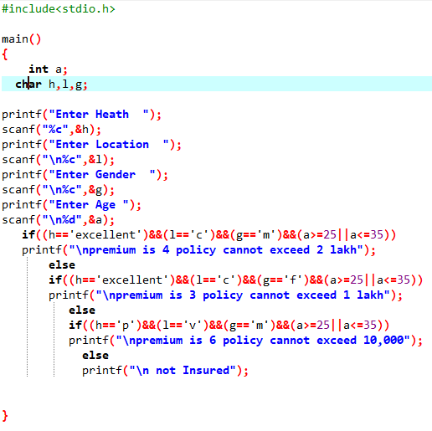

**(d)** Write a program, which will require the user to give values of hardness, carbon content and tensile strength of the steel under consideration and output the grade of the steel.

***CODE:***

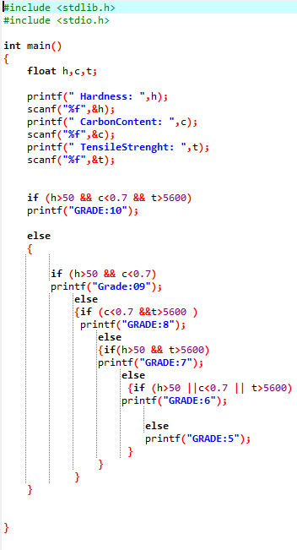

**[G]** What would be the output of the following programs:

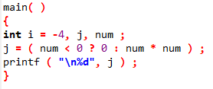(a)

***OUTPUT:***

There will be no value because “num” is not define.

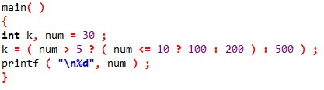(b)

***OUTPUT:***

It will be 30.

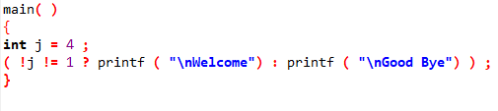(c)

***OUTPUT:***

Welcome.

**[H]** Point out the errors, if any, in the following programs:

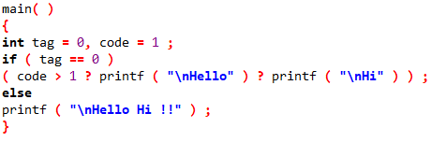(a)

***OUTPUT:***

“?” operator always comes with “:” .

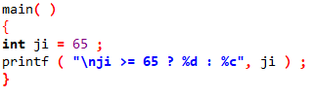(b)

***OUTPUT:***

No error.

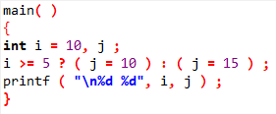(c)

***OUTPUT:***

No error.

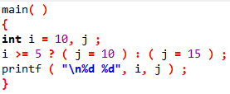(d)

***OUTPUT:***

“?” operator always comes with “:” .

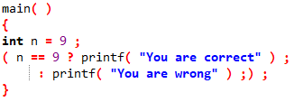(e)

***OUTPUT:***

There should not be “;” after printf statement.

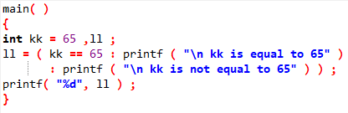(f)

***OUTPUT:***

“:” is used without any “?” operator.

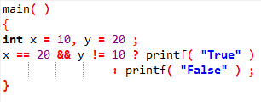(g)

***OUTPUT:***

No error.

**[I]** Rewrite the following programs using conditional operators.

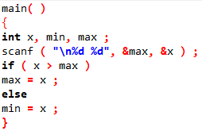(a)

***WITH CONDITIONAL OPERATOR:***

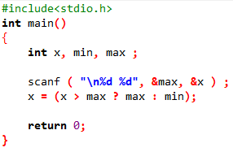

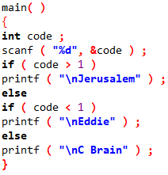(b)

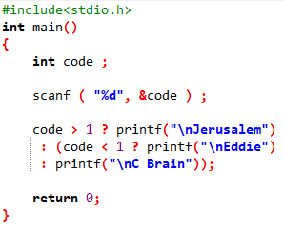***WITH CONDITIONAL OPERATOR:***

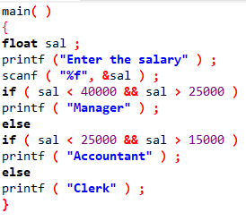(c)

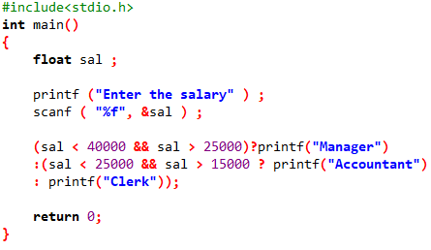***WITH CONDITIONAL OPERATOR:***

**[J]** Attempt the following:

(a) Using conditional operators determine:

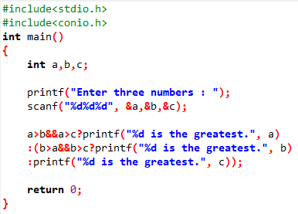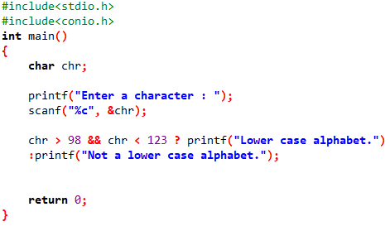**(1)** Whether the character entered through the keyboard is a lower case alphabet or not.

**(2)** Whether a character entered through the keyboard is a special symbol or not.

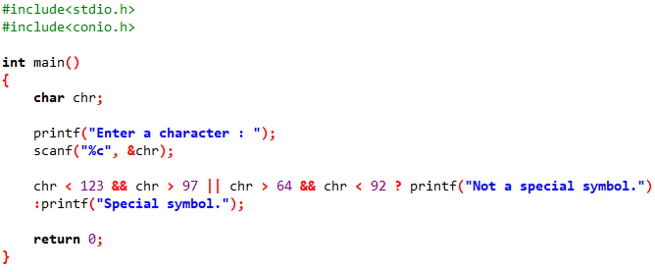

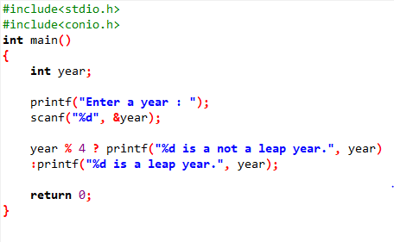**(b)** Write a program using conditional operators to determine whether a year entered through the keyboard is a leap year or not.

**(c)** Write a program to find the greatest of the three numbers entered through the keyboard using conditional operators.